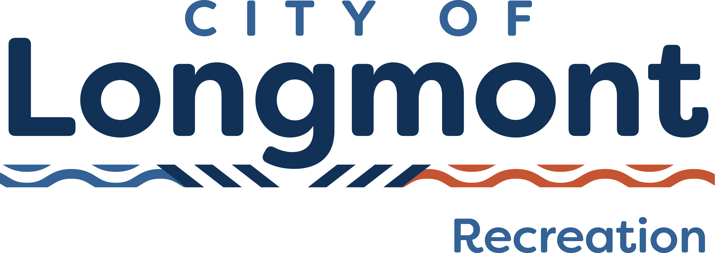
PARENT’S CODE OF CONDUCT
The City of Longmont Recreation Services appreciates the efforts of the parents in our communities helping to create a fun atmosphere for their children in our recreational programs. Those efforts include carpooling for practices and games, supporting their children’s volunteer coaches, and providing positive reinforcement for all children participating in our programs.
Unfortunately, many parents, fans and coaches don’t realize that their actions, whether verbal or nonverbal, can have a lasting emotional effect on children. Too many children are leaving sports activities because the fun is unfairly taken away by adults.
That is why we have created the following Code of Conduct for parents and spectators to abide by at every game. Parents, fans, and coaches who follow this simple code can help reinforce what sports are all about…BEING FUN FOR EVERYONE! We ask that all parents read these simple principles, sign the bottom, and return to their coach prior to the start of the first game.

As a parent or spectator:
- I will remember that children participate to have fun and that the game is for youth, not adults.
- I will learn the rules of the game and the policies of the league.
- I (and my guests) will be a positive role model for my child and encourage sportsmanship by showing respect and courtesy, and by demonstrating positive support for all players, coaches, officials and spectators at every game, practice or other sporting event.
- I (and my guests) will not engage in any kind of unsportsmanlike conduct with any official, coach, player, or parent such as booing and taunting; refusing to shake hands; or using profane language or gestures. I understand that at games, I will sit in the stands or designated area and not behind or in the player’s area. I understand that my failure to do so could result in my being asked to leave the facility.
- I will not encourage any behaviors or practices that would endanger the health and well-being of the athletes.
- I will teach my child to play by the rules and to resolve conflicts without resorting to hostility or violence.
- I will praise my child for competing fairly and trying hard, and make my child feel like a winner every time.
- I will never ridicule or yell at my child or other participants for making a mistake or losing a competition.
- I will promote the emotional and physical well-being of the athletes ahead of any personal desire I may have for my child to win.
- I will respect the officials and their authority during games and will never question, discuss, or confront coaches at the game field, and will take time to speak with coaches at agreed upon time and place.
- I will demand a sports environment for my child that is free from drugs, tobacco, and alcohol and I will refrain from their use at all sports events.
- I will refrain from coaching my child or other players during games and practices, unless I am one of the official coaches of the team.

By signing this form I acknowledge that I have read and understand this code of conduct and I agree to model my behavior after these principles. I will do my best to make my child’s athletics experiences as fun as possible! The City of Longmont Recreation & Golf Services thanks you for your ongoing positive support of all children in our community!

Signature Date

Print Name________________________________________________

